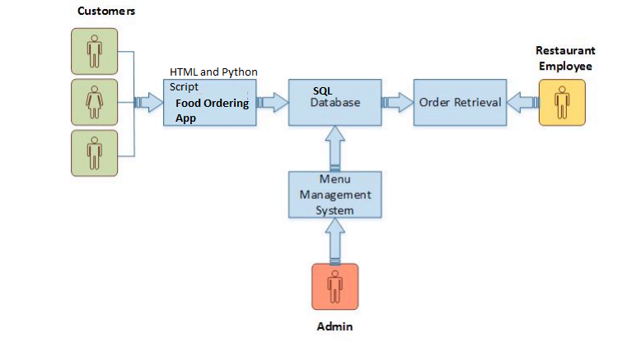

**How the System Works**

The structure of the system can be divided into 3 main logical components:

• Food Ordering System- provides the functionality for customers to place their order in the restaurant

• Menu Management-Contains a list of all the food offered in the restaurant a customer can order

• Order Retrieval System- Allows restaurant attendant to view the orders and act on the orders requested by the

This System Stores all its input to the database and when and order is completed it updates the status of the Customer orders store customer order information as well as has a library of the Hotel Menu